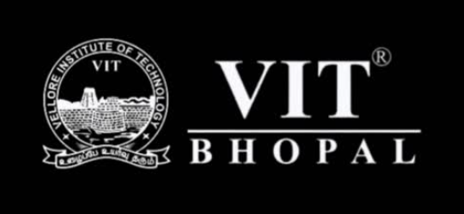

WINTER SEM 2025-26

PROJECT REPORT – DIGITAL LITERACY

NAME: RITIKA MANCHANDA

REGISTRATION NO. : 25BAI10451

BRANCH: B.TECH

COURSE CODE: CSE0001

YEAR: 1st Year

Introduction
In today’s world technology is really important for students.
Digital literacy is not about using devices but also using them safely and responsibly.
As a Student Digital Ambassador this project helps spread awareness about literacy to my peers.
The project includes tasks, like:
* making an infographic
* building a portfolio
* checking out useful online platforms
* learning email etiquette
* understanding cybercrime.
These activities helped me get better at using tools and learn how to use them in a smarter way.
I also learned how to stay online and use online tools more securely.
The project helped me improve my skills and I was able to understand digital literacy better.

Task 1: Infographic
For this task I made an infographic about literacy using Canva. The infographic is called "Digital Literacy: Skills for a Smart Future”. It talks about tools, online safety, professional presence and email etiquette. I made the design simple with not much text and used icons to make it look good. While making it I learned how to show information without making it look messy. It was cool to find a balance between the content and pictures. This task helped me be more creative and understand how to share ideas in a way with digital literacy in mind. It also helped me learn more, about literacy skills.
.

Task 2: Digital Portfolio
In this task, I created and updated my profiles on platforms like GitHub and LinkedIn. These platforms help build a professional online presence and showcase skills. On GitHub, I wrote a profile README with my basic details and learning goals. On LinkedIn, I added my education information. This task helped me see how important it is to maintain a professional identity online. In the future, I plan to keep updating these profiles with my work and achievements.

Task 3: Platforms
For this task, I explored both coding and collaboration platforms. I completed a beginner-level coding problem, which helped me understand basic problem-solving.
I also created a Google Form quiz on digital literacy. This helped me learn how to collect and analyze responses using Google Sheets. These tools are useful for both academics and teamwork, and I will continue using them in my studies.

Task 4: Email Etiquette
I did a task where I had to write emails that sounded professional and make a list to help with using media. I found out that it is really important to write lines that make sense be nice in the emails and keep them short and easy to read. If you do not communicate well on the computer it can be very confusing. For example if you send an email that does not make sense the other person might get. It might take them a long time to do what you asked. This task really helped me to get better at talking to people and I learned how to be professional, on the internet. I improved my email writing skills. I understand now how to use social media in a professional way, which is pretty cool.

Task 5: Cybercrime Awareness
I was doing this task. I found out about cybercrimes. Cybercrimes like UPI fraud are really bad. People can easily become victims of cybercrimes. I was surprised to see that lots of scams happen because people trust calls or links from people they do not know. People trust them without checking if they're real or not. This made me think that I need to be very careful when I use platforms. I will not share my details with anyone. I will check payment requests carefully. I will stay alert when I am online. Doing this task helped me learn more about cybercrimes like UPI fraud. Now I know what to do to stay safe. I will use platforms in a safer way. I will remember to be careful with cybercrimes, like UPI fraud.

Conclusion
This project really showed me how important digital literacy is in the world we live in today. I got to learn how to use tools and how to communicate with people in a professional way. I also learned how to stay safe when I'm online. Every task I did helped me learn things and get better at using digital tools. The digital literacy project was really helpful. I think it will make a big difference for me when I am, in school and when I have a job. Digital literacy is something that I will keep using. It will help me a lot.
References
Canva
Google Forms
GitHub
LinkedIn
cybercrime.gov.in

